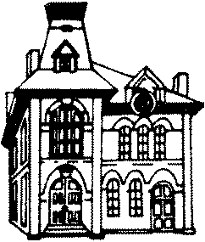
LaGrange Utility Department
301 Liberty Street
LaGrange, Ohio 44050
Utilities@villageoflagrangeohio.gov

CONTACT INFORMATION UPDATE FORM
As time passes, people change phone numbers, place of employment, and even on occasion, their name. It is important that we are able to contact residents in a timely manner, especially during an emergency. Updated account information is needed, such as current telephone numbers and e-mail addresses. Kindly fill out the form below and return it to the Utility Office by mail, in person, in the after-hours box, or by email. Please print clearly to ensure accuracy of phone numbers and email addresses.

First name: ____________________________ Last Name_______________________________
Service Address: ________________________________________________________________
Phone Number: __________________ Secondary number (if available): ___________________
Email address: __________________________________________________________________
Name of Employer: ______________________________________________________________
Phone Number of Employer: _________________________
Emergency contact in case you cannot be reached:_____________________________________ ______________________________________________________________________________
______________________________________________________________________________

