
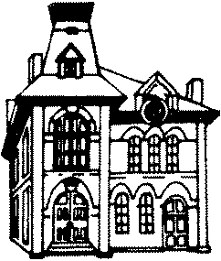

301 Liberty Street
LaGrange, Ohio 44050
(440) 355-5555
Fax 440-355-5250

Founded 1875

Village Residents,

The following meetings and events are scheduled for September 2023.
All meetings are at the Municipal Building unless stated otherwise.

Thursday September 7th
Planning Commission 7:00 PM

Tuesday September 12th
Park Board 7:00 PM

Thursday September 14th
Special Meeting – Email Set-up 6:00 PM
Committee of the Whole 6:45 PM
Council 7:30 PM

Tuesday September 26th
Park Board 7:00 PM

Thursday September 28th
Council 7:30 PM

The Municipal Building will be closed Monday September 4th in observance of Labor Day.
Trash will be delayed one day.

