(LaGrange, Ohio),
Happy New Year from Republic Services®! Thank you for allowing us to serve you in past years, and again in 2020.
One of Republic Services’ key 2020 goals is to reduce recycling contamination. In other words, we want to make sure people are only putting plastics, aluminum, paper, cardboard and glass in their recycling containers.
For plastics, residents should do the poke test — if you can poke your finger through the plastic, then it is too flimsy to recycle.
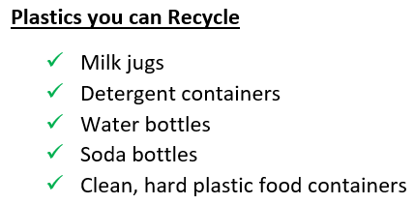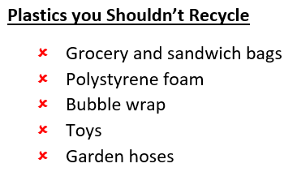

For aluminum, residents should empty and clean their material and follow instructions below:
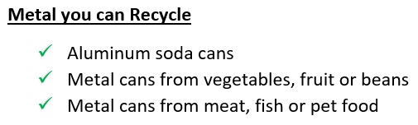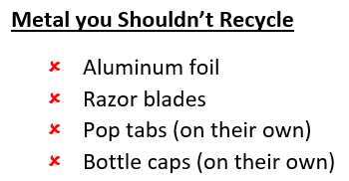

Paper should always be separated from plastic, even if from the same packaging. Here are some rules for paper recycling:
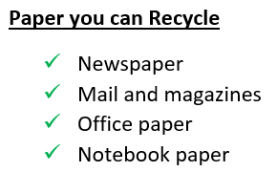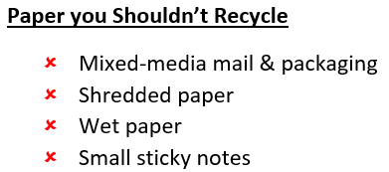

Recycled cardboard should be a clean, unsoiled product:
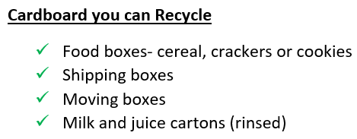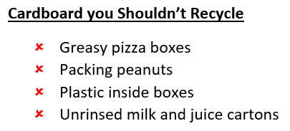
Republic Services has created RecyclingSimplified.com to provide clear educational information for residential recyclers, but we need your help in getting this educational information to your residents.
Here’s how you can help your residents recycle responsibly:
- Share this letter with residents
- Tell residents the five things they can recycle (via newsletter, email, etc.)
- Update your website to reflect current recycling guidelines
- Post a link to RecyclingSimplified.com on your website
- Include recycling information in your welcome packages to new city residents
Republic Services will also be doing its part to educate residents:
- Our recycling center located at 43650 Oberlin Elyria Road is available for tours, so any residents are welcome to schedule a tour and visit.
- Republic Services is hitting the streets and looking inside recycling containers; in some places, we are putting “Oops” tags or “Thank You!” tags on containers to correct/reinforce behavior. In other places, we will be putting stickers on containers showing what to recycle.
- Republic Services plans to begin auditing and grading recycling loads from cities; we hope to provide your city with a report on the state of your city’s contamination.
With the recycling industry struggling due to China’s exit from the commodity market, recycling responsibly has never been more important. Our plant is not built to process waste, it can only process recyclables in our program. Therefore, your partnership in educating residents to recycle responsibly is essential and wholeheartedly appreciated.
Please contact Lisa Beursken (LBeursken@Republicservices.com), Republic Services Recycling Coordinator, or John Conroy (JConroy@Republicservices.com), Republic Services Leadership Trainee, with specific recycling questions. We look forward to making 2020 a year of responsible recycling! Please let us know how we can help you and keep us in the loop about your efforts.

With gratitude,
Republic Services

